Project Code | R166 | Project Sponsor | Alberto Matucci
Project Name | Composite Flexible Pipe | Project Manager | Jim Latto
WBS | xxx | Principal Engineer | Neville Dodds
Document Ref | R166Exxx | Owner | Richard Clarke
Revision | P | Revision Date | 19/01/17
Work Package Title | Mid-scale Testing – Combined Loads

Work Package Summary
Description of test / group of Tests within work package. Why is the test / group of tests needed? What will data generated from this test / group of tests be used for?

This work package contains all combined load mid-scale qualification and verification tests and their associated support packages (e.g. Design and build work for bespoke testing capability).
Combined load refers to tests carried out on pipe samples up to the composite pressure armour where load is applied in more than one principal direction. For example, bent collapse, creep-burst, bend-creep (stress rupture) and pressure-bend can be considered combined load scenarios.
The majority of the tests will be used verify modelling, design and analysis. However, tests related to qualification and verification (When mandated by DNV, API or clients) will be verified / checked by the IVA.

Work Package Deliverables
Specific deliverables, numbered with specific references to the project WBS and any relevant documentation that raises the requirement (API / DNV / FMECA Item etc.)

Main deliverables are detailed understanding of Bent collapse (of a pipe design is subjected to bent collapse the same design must also partake in straight collapse testing, in this case an 8” pipe design has been utilised. Creep-burst utilising a 6” pipe design is also to be performed, the planning and management of which has been incorporated into “Mid-scale Single Load case” summary sheet.

Bend Creep : Stress Rupture at 8 inch will performed.

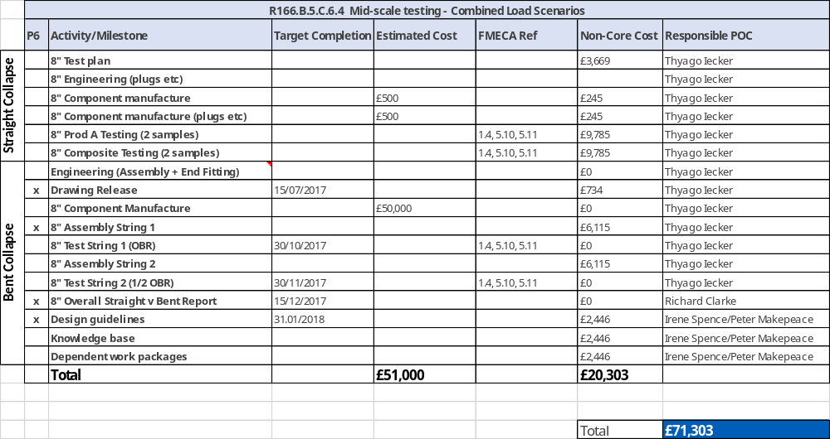

Work Package Links / References
Reference documents and links to documents (Where possible)
Examples: API 17xx, DNV RP xx, FMECA - R166Exxx, Procedure - WSI ENGxxx, Design and business reviews

1. FMECA - Hyperlink
2. DNV RP's- Hyperlink
3. API- Hyperlink
4.
5.
6.
7.
8.
9.
10.
11.
12.

